SPEAKING FOR UNIT 1

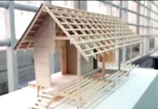  1 | 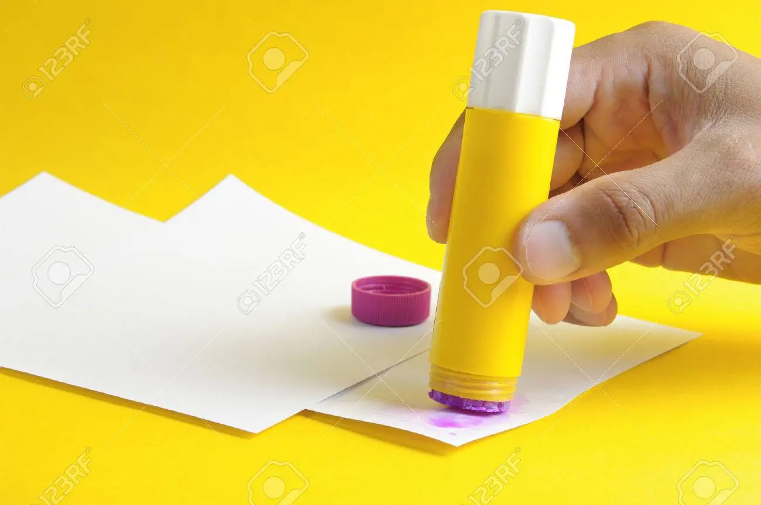  2 | 3 | 4
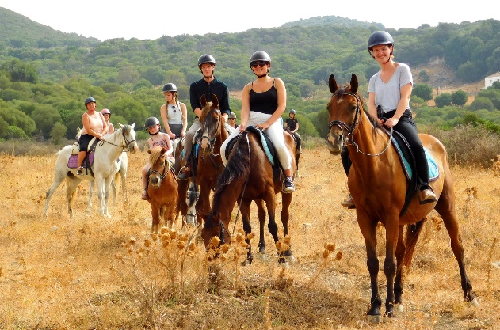  12 | - What is her/his hobby?  - What does/ do (she /he/they) like doing?  - What does/ do she /he/they like doing in the summer/spring?  - It’s an activity that helps your hands and eyes work well together.  - It is an activity that helps you learn about flowers, fruits, vegetables and insects.  - It is a noun that means ‘ the duty of taking care of something’ |  | 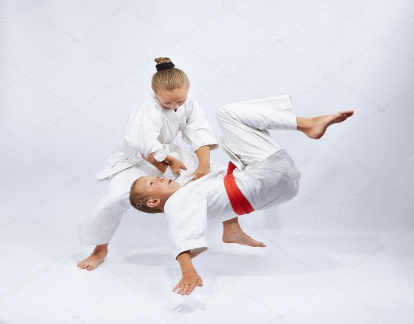  5
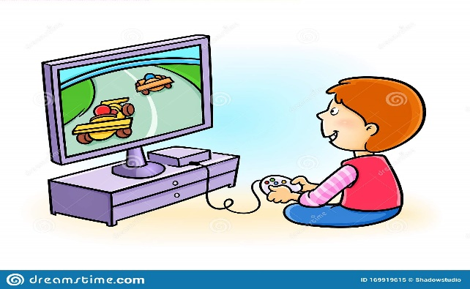  11 |  |  | 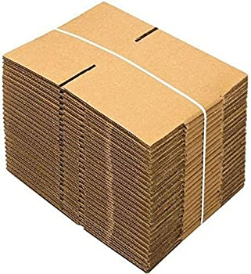  6
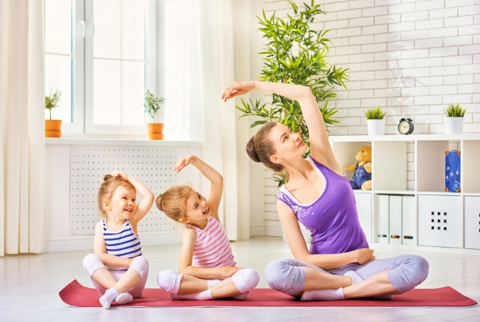  10 | 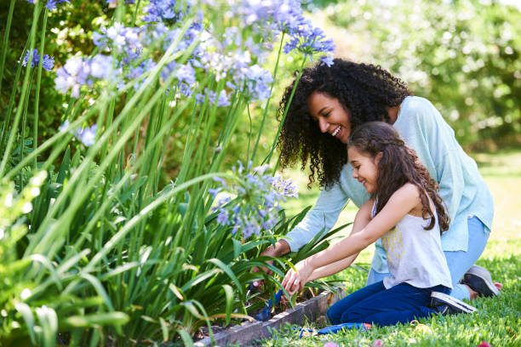  9 | 8 | 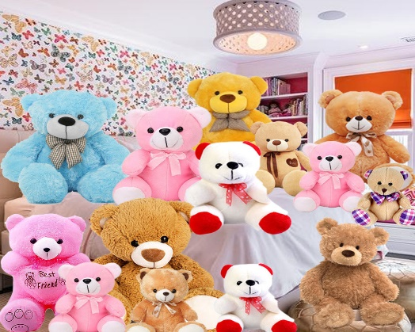  7
INTERVIEW

2. What is your favourite hobby?
3. When did you start this hobby?
4. Who do you share your hobby with?
6. What do you need for this hobby?
1.How much free time do you have a day?
5. What is its benefit? What benefit do you get from this hobby?
ROLE PLAY

