UNIT 2: HEALTHY LIVING
A. Introduction - 0.4 pt (~3 ideas):
Share something about your hobbies/ school/ friends/
B. Cue pictures (Vocabulary) – 1.0 pt (~5 questions):
1 | 2 | 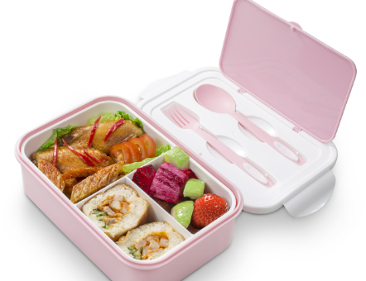  3 | 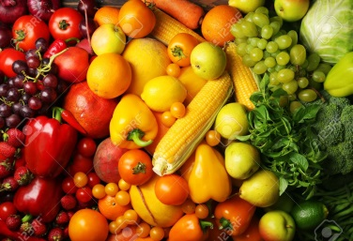  4
12 | 1. What is her/ his problem? 1/5/8/10  2. What problem does he/ she get? 1/5/8/10  3. It is an activity that helps you keep fit. 6/9  4. It’s one of the ways to protect you from COVID-19. 2/12  5. What happens when you go out without hat and suncream? 1  6. This food helps you have a good health. 4 |  | 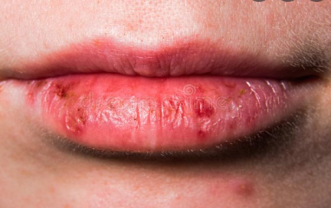  5
11 |  |  | 6
10 | 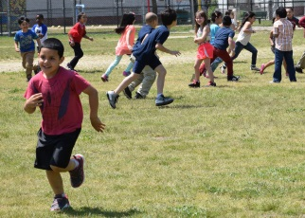  9 | 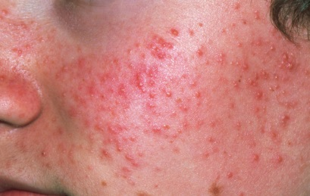  8 | 7

C-Interview/ Role-play – 0.6 pt (~3 questions/ 1 student)

Student A - B/ / Student - Teacher
1. How should you wash your face?
2. What food is good for your health?
3. How many hours a day do you need to sleep?
4. What activities do people often do to keep fit?
5. What do fruit and vegetables provide with?
6. What do healthy habits help you avoid?

