SPEAKING TEST ENGLISH 7
UNIT 3: COMMUNITY SERVICE
A. Introduction: (0.4 pt)
B. Pictures Cue (Vocabulary): 1.0 pt (5 questions):
1  2  3  4  5  6  7  9  10  11  12  8 | 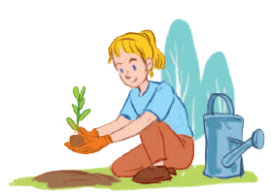
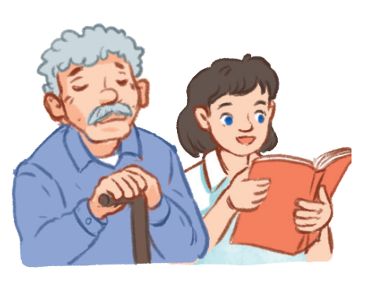 | What’s this?/What are these? (1,9)  What does she like doing? (2,7,11,12)  What did they do last summer?(4,5,10)  It’s an activity that helps the old people relax?(4,12)  It’s an activity that helps the street children to learn?(11)  It’s a verb that means giving s.th to s.o/ helping children how to know to read and write. |  | 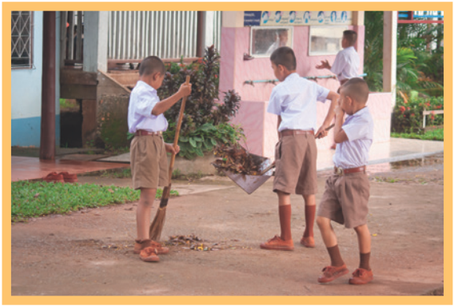
 |  |  | TUTOR
 |  |  | 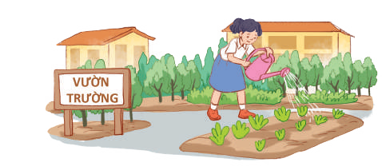

C. Interview/ Role-play:
Questions
- What do you often do in your free time?
- Which activities do you take part in to help community?
- Who do you often work with in this activity /these activities?
4. How often do you do this activity?
5. When did you last join this activity?
6. Why do you want to join this activity?

