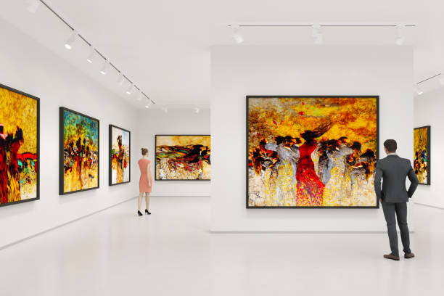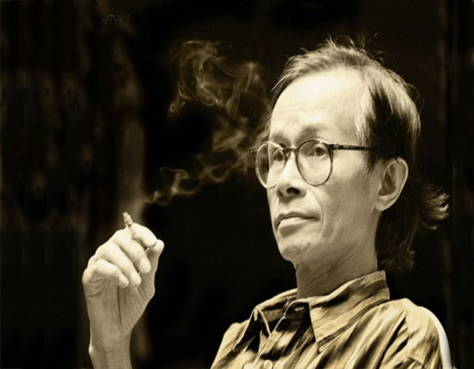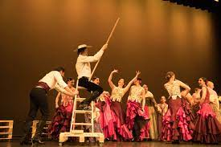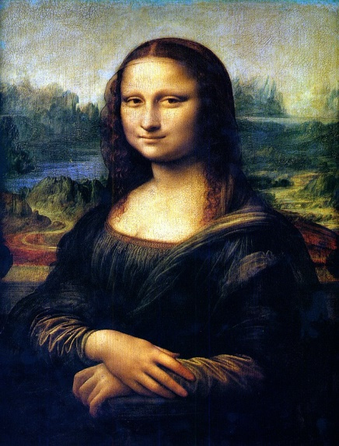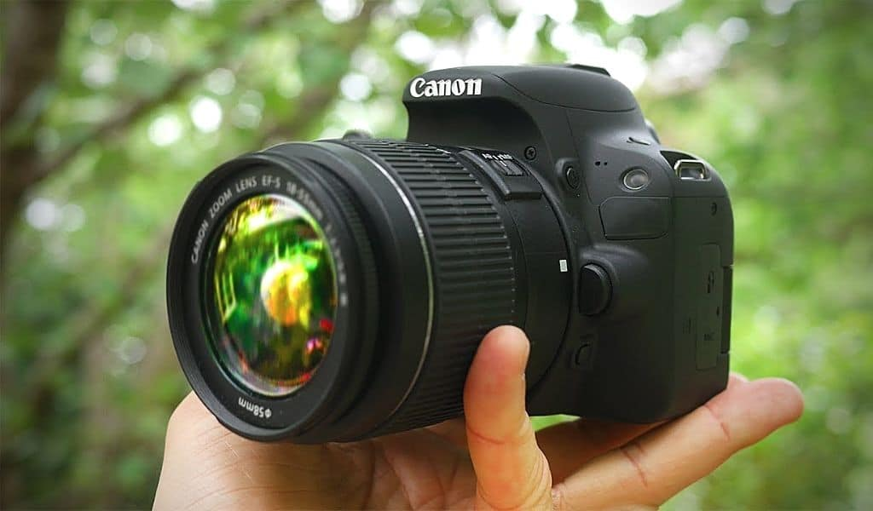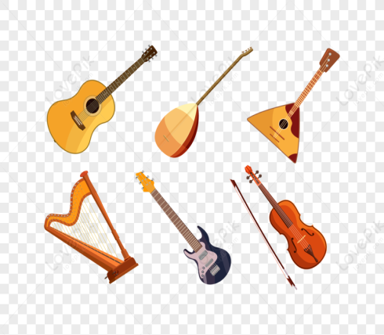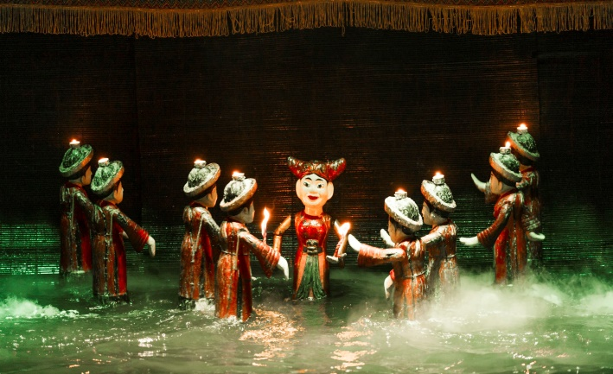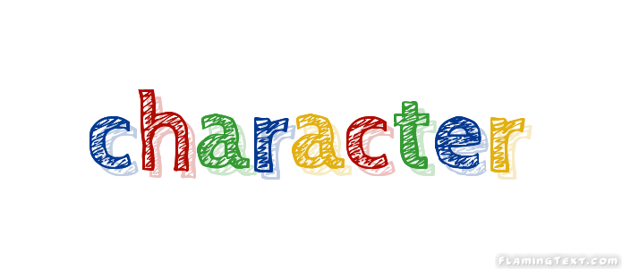

**II. TOPIC SPEAKING: UNIT 4**

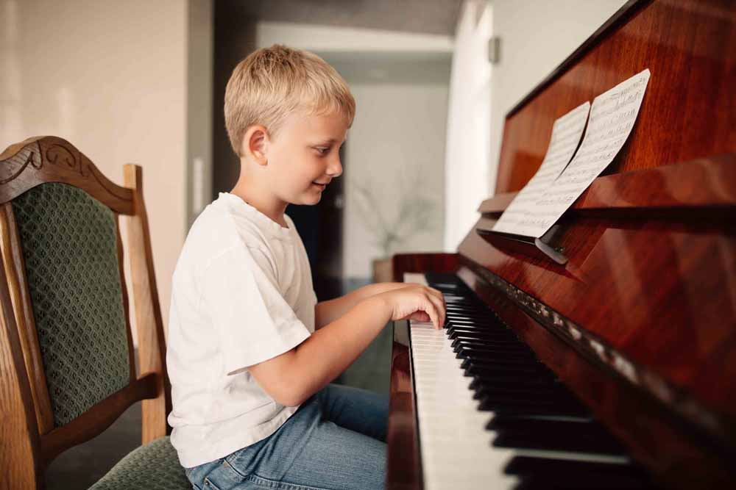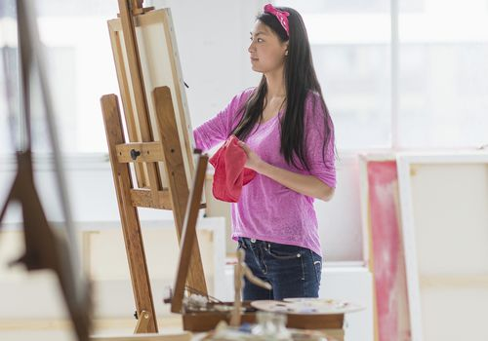

1. What is this? (p2, 3, 6, 9)
2. What can you see in the picture? (p2, 3, 6, 9)
3. Where is he/she? (p8)
4. What is she doing? (p 4, 7, 11, 12)
5. What does she/he prefer doing? (p7, 4, 11, 12)
6. It is a traditional Vietnamese art form which artists perform in a pool. (p1)
7. This is a person who writes songs. (p10)
8. This is a person or animal in films.(p5)

**6. Who is your favourite composer/ singer/ artist?**

**5. What kind of music do you prefer?**

**4. Who do you often go to the concert/ theater/ art gallery/ cinema?**

**1. Can you name some musical instruments?**

**2. What kind of musical instrument can you play?**

**3. How often do you go to the concert/ theater/ art gallery/ cinema?**

**III. QUESTIONS AND ANSWERS: UNIT 4**