SPEAKING TEST FOR UNIT 5 – ENGLISH 7
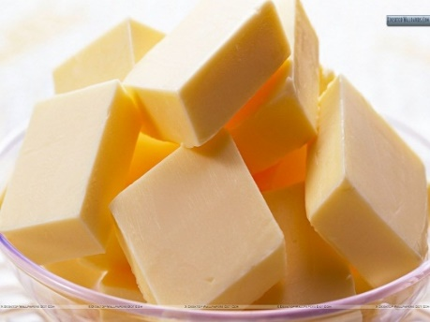  1 | 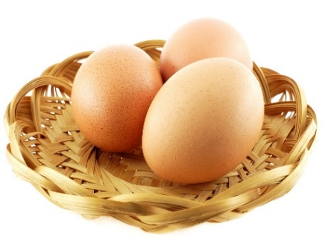  2 | 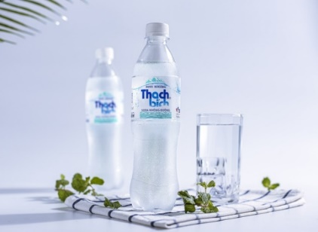  3 | 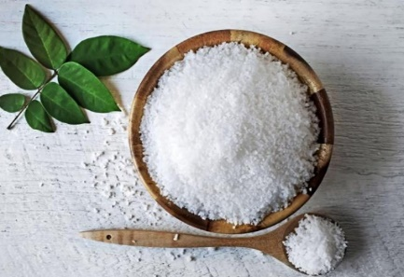  4
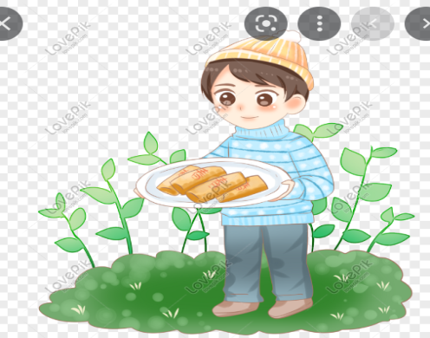  12 | - What food / drink is this? (2,3,5,8,9,10)  - What’s his / her favorite food / drink? (7,12)  - What does he / she have for breakfast / lunch /dinner? (5,7,12)  - What food can he / she cook? (11)  - What food / drink does he / she want to try? (7)  - It’s a kind of food that is made from eggs, butter, salt and pepper. (1,2,4,6)  - It’s a kind of drink that is made from water, and tea leaves. (9) |  | 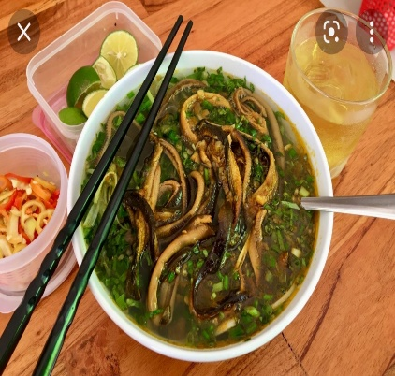  5
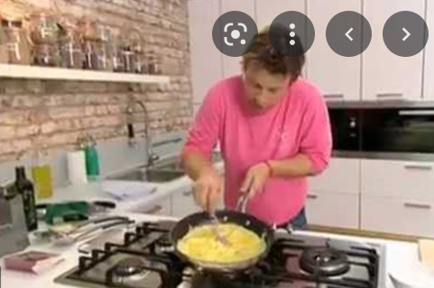  11 |  |  | 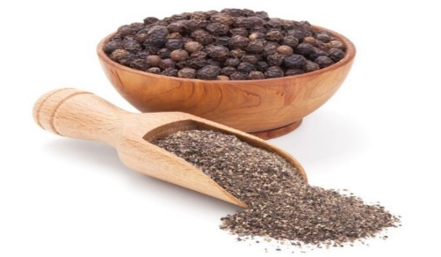  6
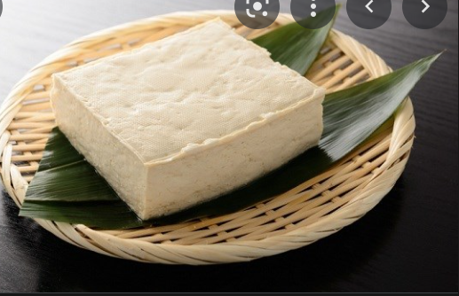  10 | 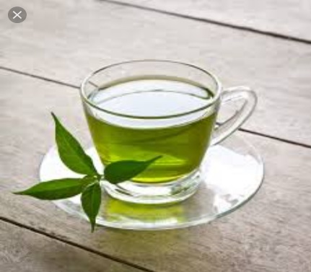 | 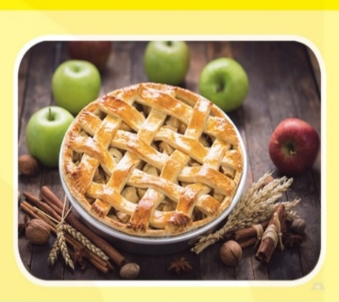  8  9 | 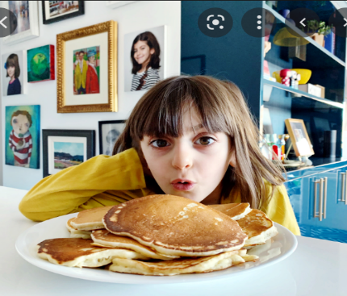  7

III. INTERVIEW / ROLE PLAY
- What time do you have breakfast / lunch / dinner?
- What do you have for breakfast / lunch / dinner?
- What’s your favorite food / drink?
- When do you usually have it?
- Do you think it’s good for your health? Why or why not?

